G00361128

Student – Tomas O’Malley

2019 Twenty Five game Hand Up

Objective: To create a functioning game of twenty five

Result: I found it extremely difficult to incorporate this game into C code. My main issue was taking the five random cards and showing how they are worth more in the suits whether the suit is high or low. My biggest issue which I couldn’t solve was my program was displaying the cards place in the array rather than the card itself.

Screenshots:

The game opens asking you to press 2 or 6 :

2-being a 2 player game

6-being a 6 player game

If you fail to enter either the game will terminate

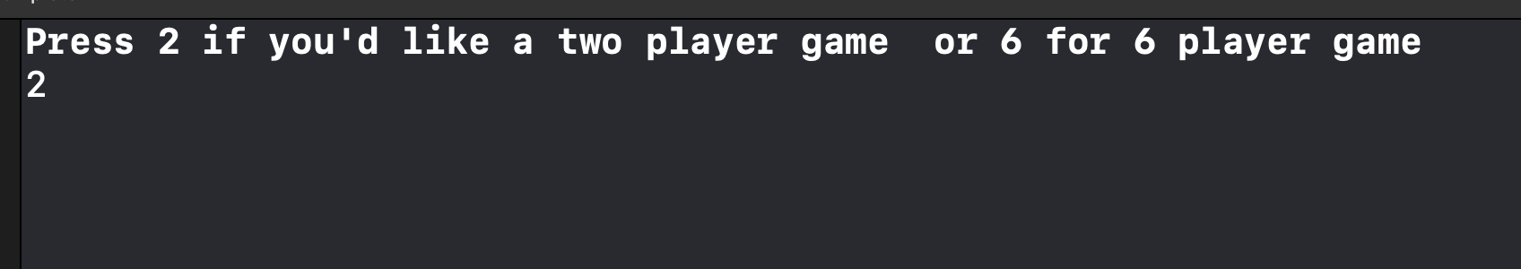

If you don’t enter 2 or 6 the program will exit

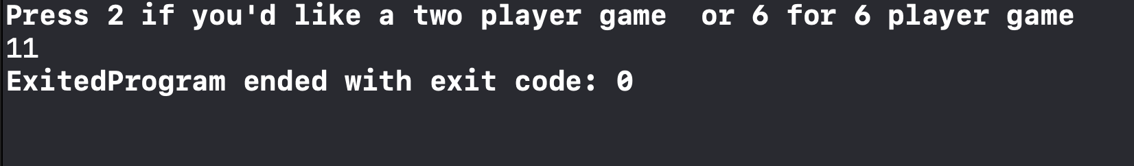

If you press either 2 or 6 the game will open and show the deck , shuffled deck and the cards

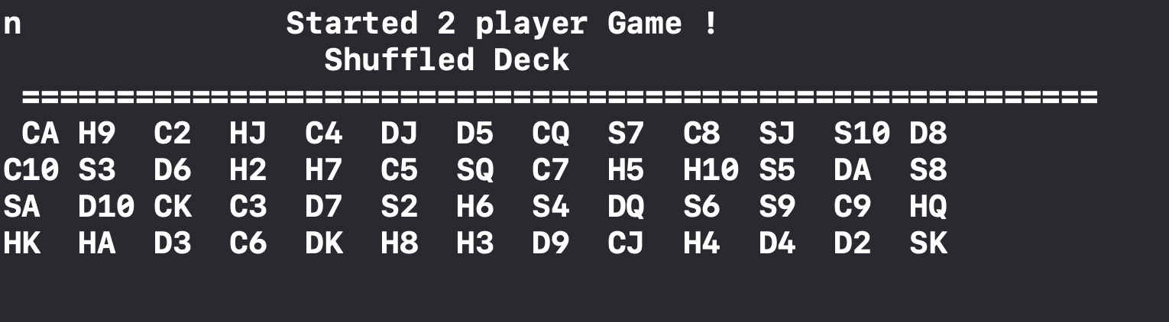

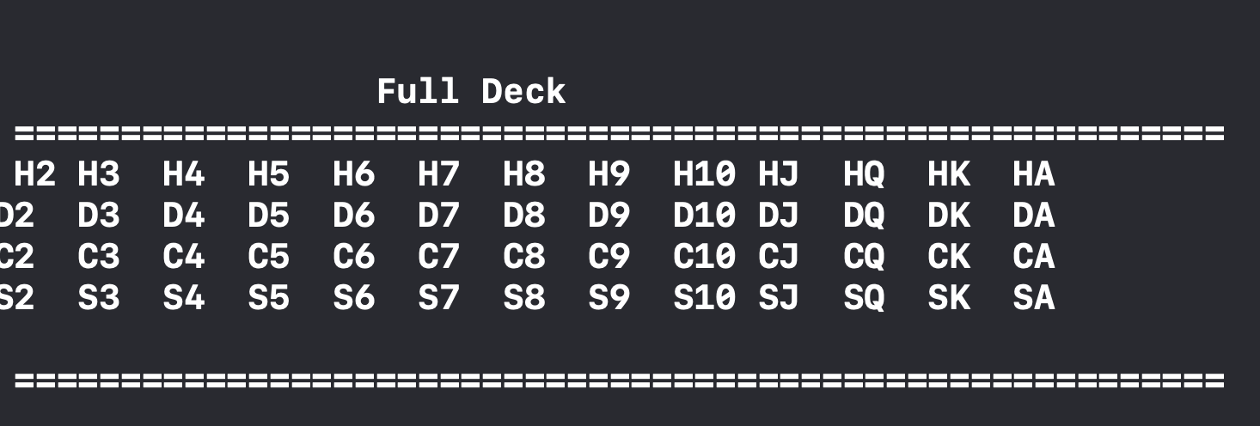

Next the game shows each of the players cards

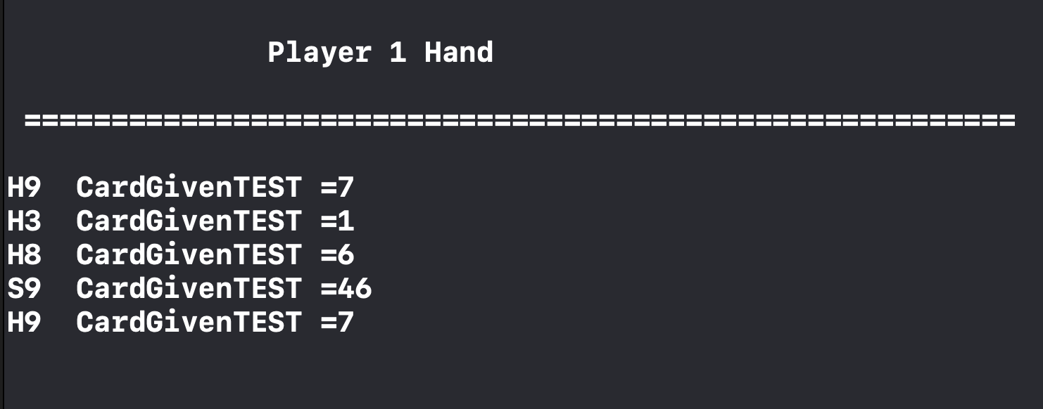

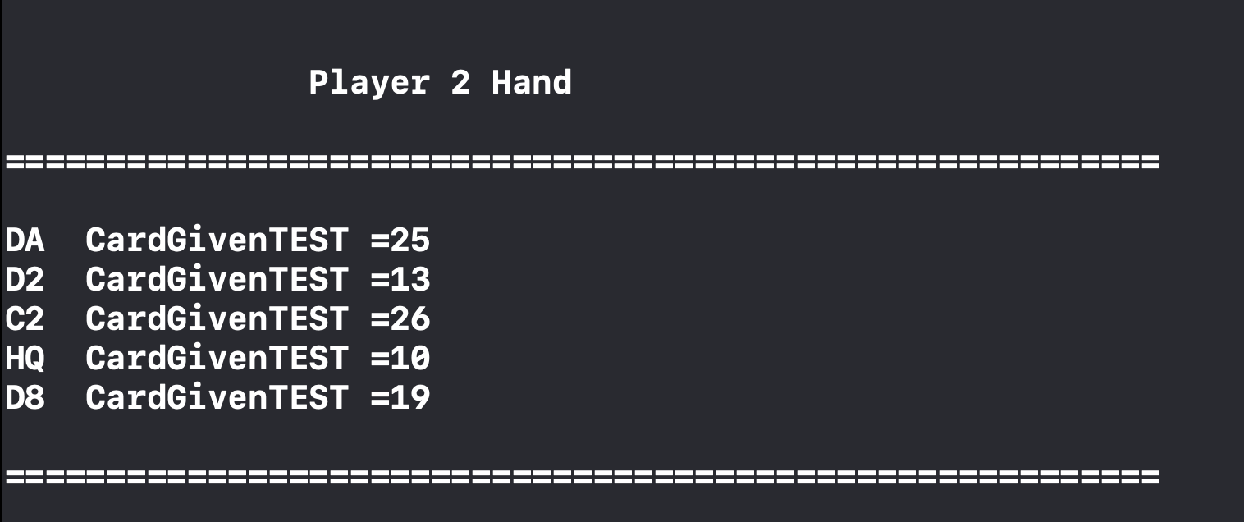

Followed by the trump Card

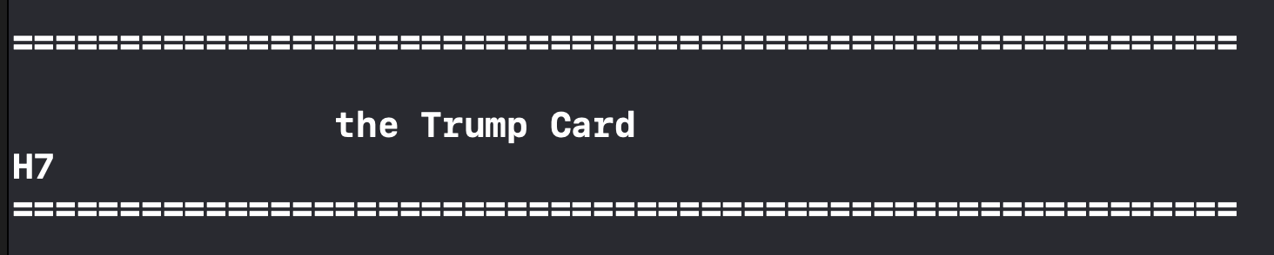

As shown in my screenshots all my cards show the place in the array rather than the card and I couldn’t progress on to play the game

Here is a screenshot of the whole attempt , thank you.

